Lab 11
Cisco IOS device hardening
Objective:
The purpose of this lab is for the student to understand configuration and implement remote access VPN using Cisco ASA and AnyConnect Secure Mobility Client
Diagram:
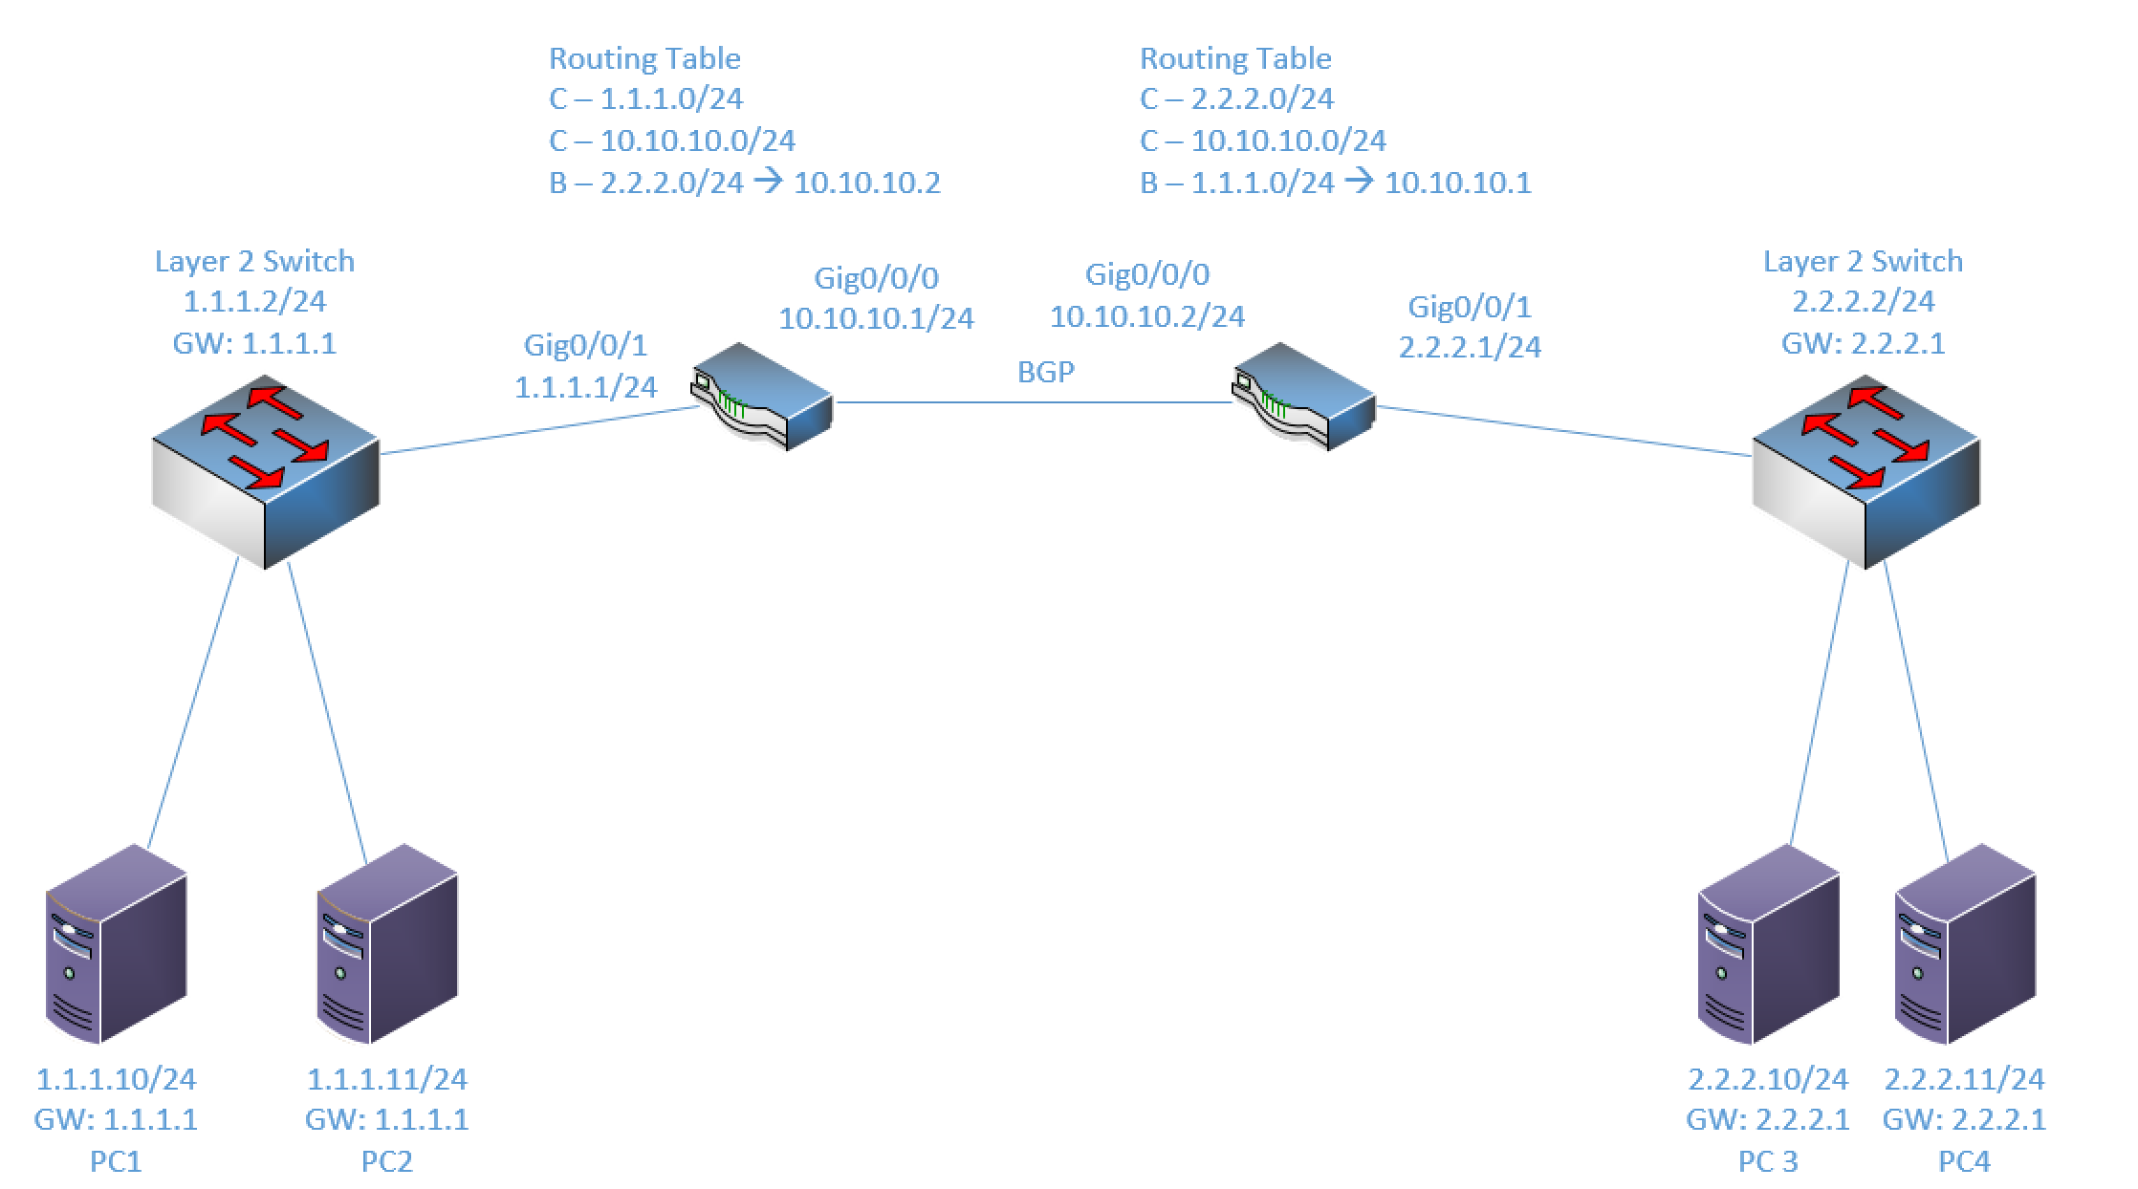
Components:
4 – PCs
1 – Cisco 3650 Layer 2 Switches
2 – Cisco 4321 ISR Routers

Useful commands for this lab

This lab will use Cisco IOS devices to configure secure Management, Control and Data plane options.
Procedure:
- Connect all PCs, switches and routers as shown in the diagram above.
- Configure the IP addresses on the router interfaces as shown above. The routing tables and interface IP addresses are all shown above.
- Configure IP addresses, subnet masks and gateways on PCs.
- Confirm PCs on same network can ping each other and their gateway.
- Configure BGP between Route 1 and Router 2
  - Router 1:
router bgp 1
neighbor 10.10.10.2 remote-as 2
neighbor 10.10.10.2 password Netcom230@#)
neighbor 10.10.10.2 ttl-security hops 100
network 1.1.1.0 mask 255.255.255.0
  - Router 2:
router bgp 2
neighbor 10.10.10.1 remote-as 1
neighbor 10.10.10.1 password Netcom230@#)
neighbor 10.10.10.1 ttl-security hops 100
network 2.2.2.0 mask 255.255.255.0

- Confirm BGP is established between the two devices. Use the “show ip bgp neighbor” and “show ip bgp summary” commands. Paste the output below.
Router 1:

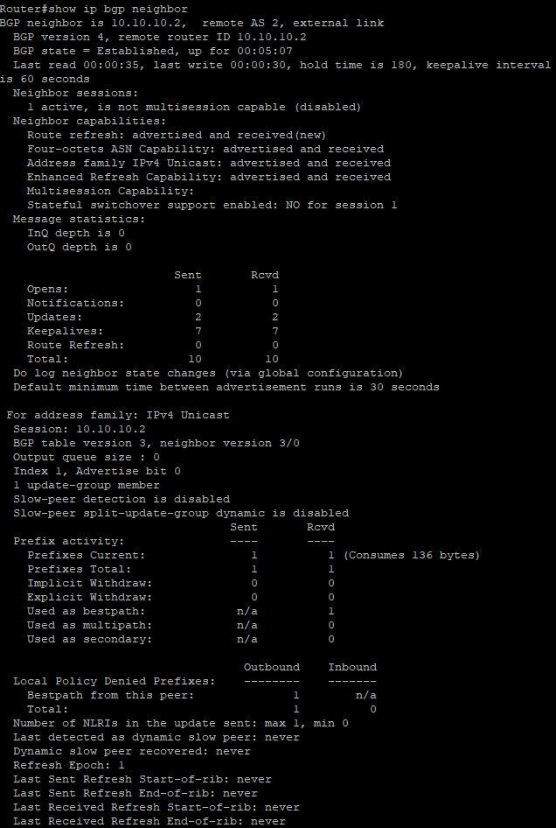
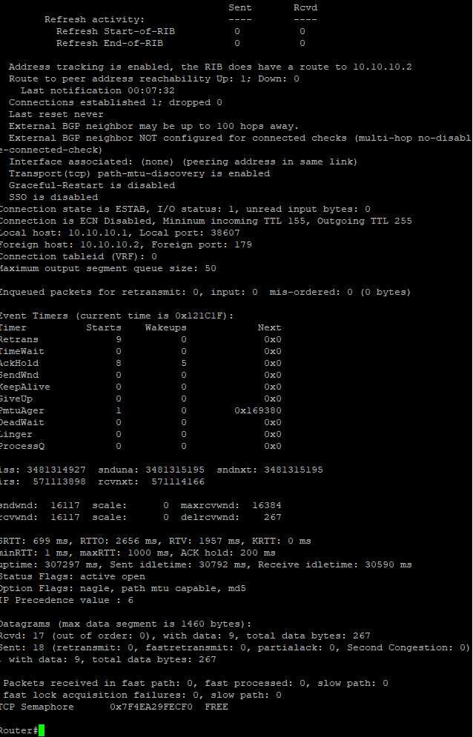
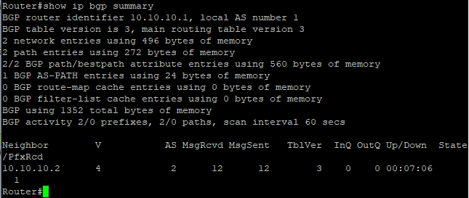
Router 2:
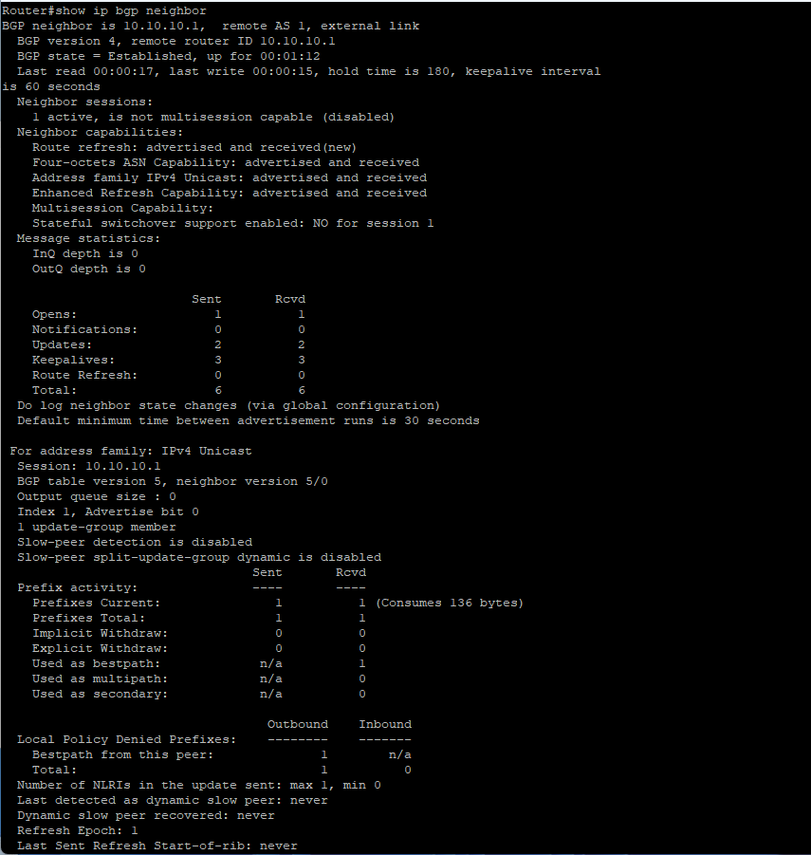

- Once you’re able to ping between the devices, configure SSH on both routers securely using the lab commands document included.
  - Configure the SSH ACL so that 1.1.1.10 and 2.2.2.10 can SSH into both routers, but 1.1.1.11 and 2.2.2.11 are both blocked. Remember, there is an implicit deny at the end of your ACLs so you only need two entries on each router to permit the two endpoints ending with .10.
- Configure a login banner using the lab commands doc with the following message:
banner login #
UNAUTHORIZED ACCESS TO THIS DEVICE IS PROHIBITED
You must have explicit, authorized permission to access or configure this device.
Unauthorized attempts and actions to access or use this system may result in civil and/or
criminal penalties.
All activities performed on this device are logged and monitored.
#
- Use Putty to log into each router from the workstations ending with .10.
  - Screenshot your banner on one of the routers and paste below
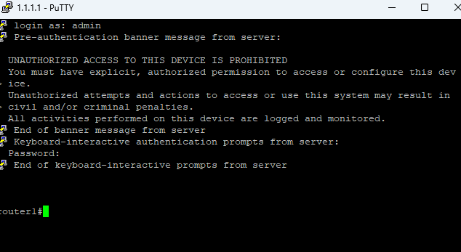

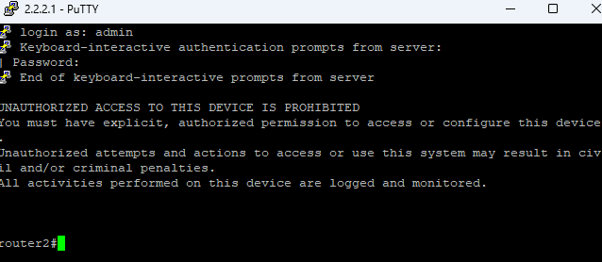

- Try to log into the devices from the workstations ending with .11. Were you successful?
  - This should be denied. Paste the rejection message below
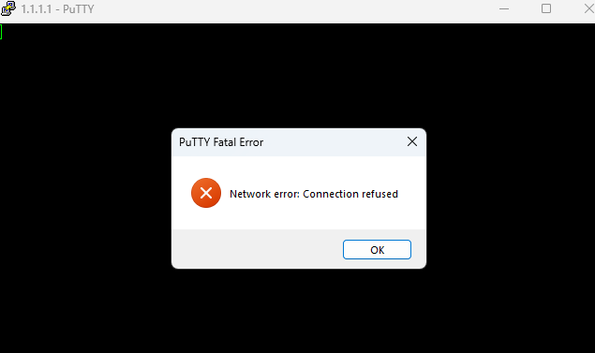
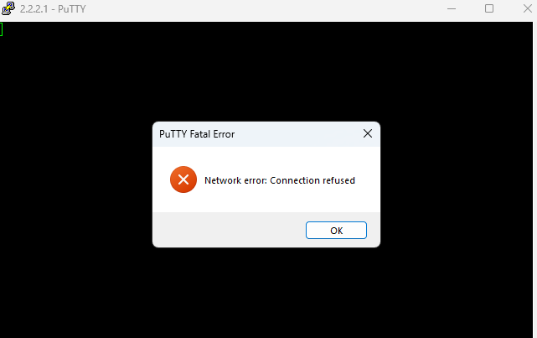

- Next, add the control plan security options to the interfaces.
interface gig 0/0/0
no ip redirects
no ip unreachables
no ip proxy-arp

- These are a little tougher to prove they are working, so just take a screen shot of your interface config and paste below.
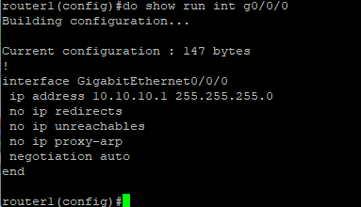
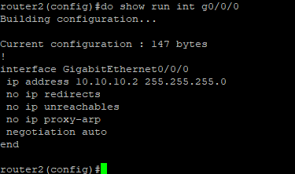

- Next, configure the data plane security options listed in the command sheet. Disable ip options, ip source-route and ip redirects. Create an ACL to block fragmented packets. and enable uRPF. Take a screen shot of these config options and paste below.
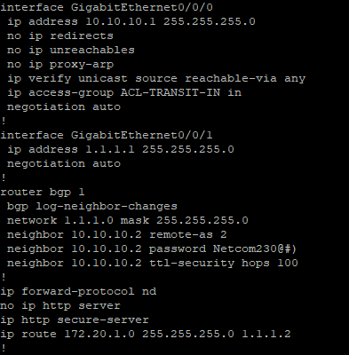
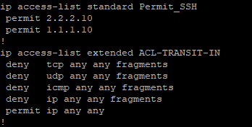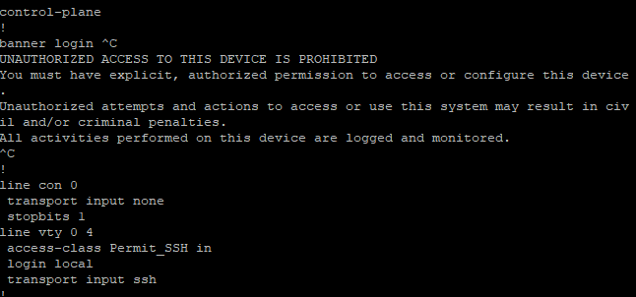

- If you would like to have a discussion about any of these options and their use cases, feel free to see me during class. I can find additional material and lab examples if you’d like.
- Draw the lab diagram below (PCs, firewall and switch connections) Label the IP addresses, subnet masks, and gateways used by each device. Label the routing tables next to the routers.

